**Create a S3 bucket and store an object in it. Enable to Object for public access so that anyone**

**can access it through a web browser**.

1. In the storage service session select S3. Alternatively, you can search for S3 in the search box.

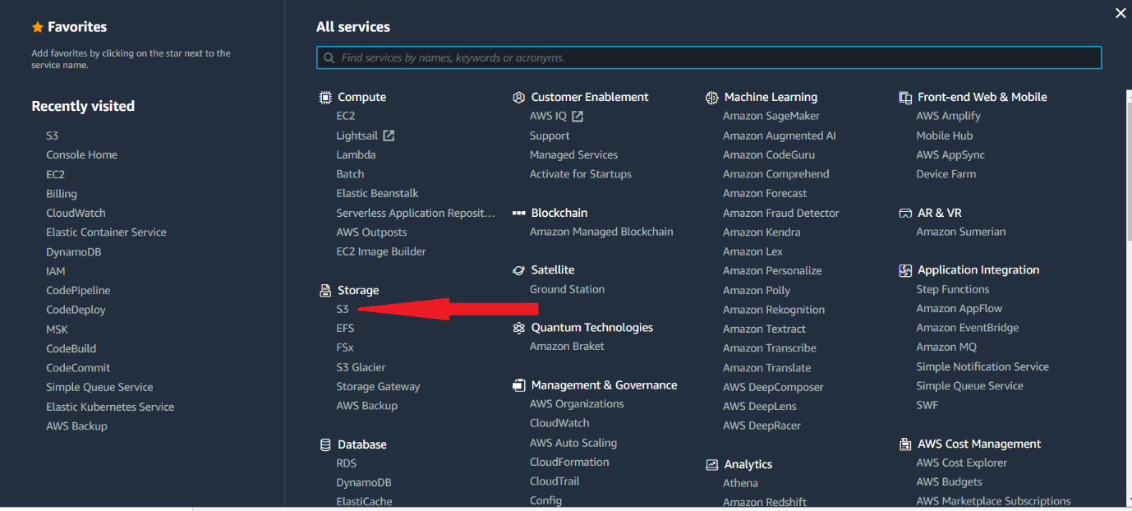

1. Click on the create bucket button as shown in the below screen
2. You will be taken to create bucket screen, where you can give a name for your bucket.
3. Bucket name should be **globally unique**. Which means no other account or user should have a bucket with that name.
4. Bucket naming conventions.
   1. No Uppercase
   2. No underscore
   3. 3 to 63 characters long
   4. Must not be an IP
   5. Must start and end with a lowercase letter or a number
5. Once the name is given, you can select the region where the bucket resides.
6. You can set the public access configurations
7. You can enable bucket versioning
8. You can create tags
9. You can specify the server side encryption and advances setting where you can enable/disable object locks etc.
10. For the hands on accept all defaults and click on the “Create Bucket” button at the bottom.
11. Once successfully created, you will be taken to the below shown screen.

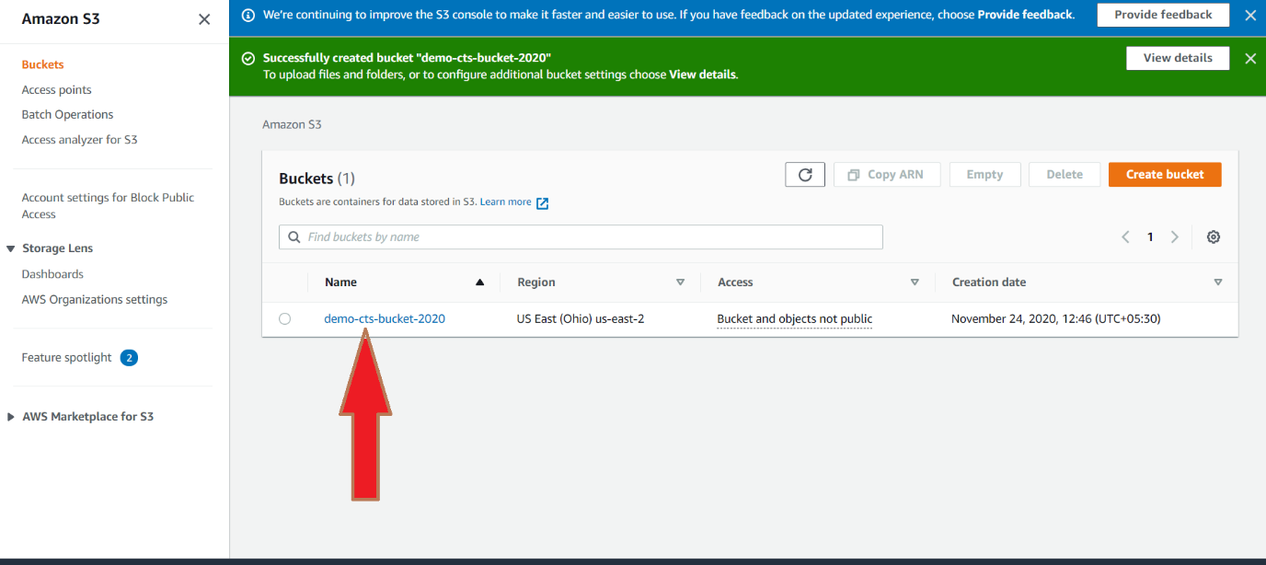

1. Click on the bucket name
2. You will be taken to the screen shown below, where you can upload files, create folders etc.

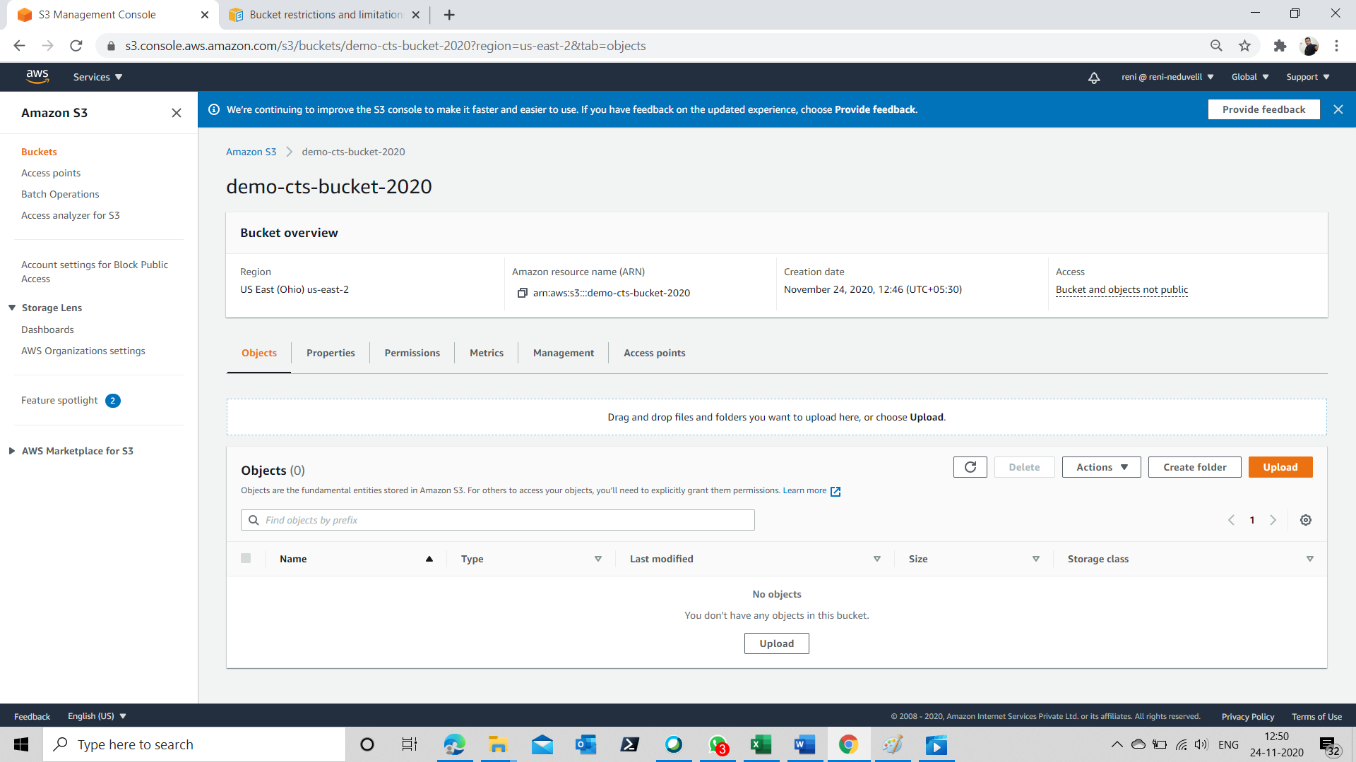

1. If you want to organize your objects inside the bucket, you can create folders, else you can directly put the object in the bucket.
2. Click on the “Upload” button.
3. You will be taken to the screen shown below. You have now the option of uploading an individual file or you can upload an entire folder.

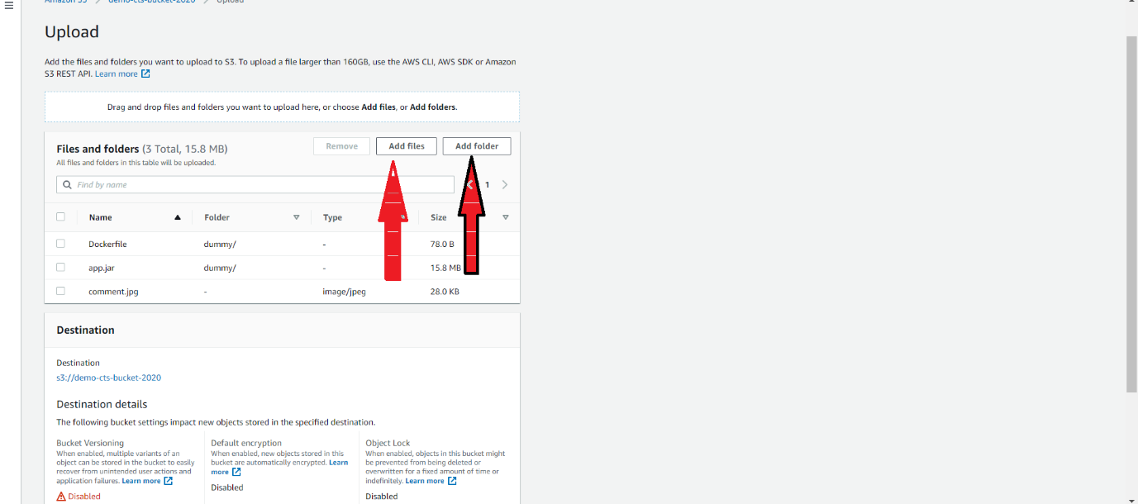

1. Once you click on the “Upload”, files and folders will be uploaded and you will be taken to the Upload: status screen as shown below.

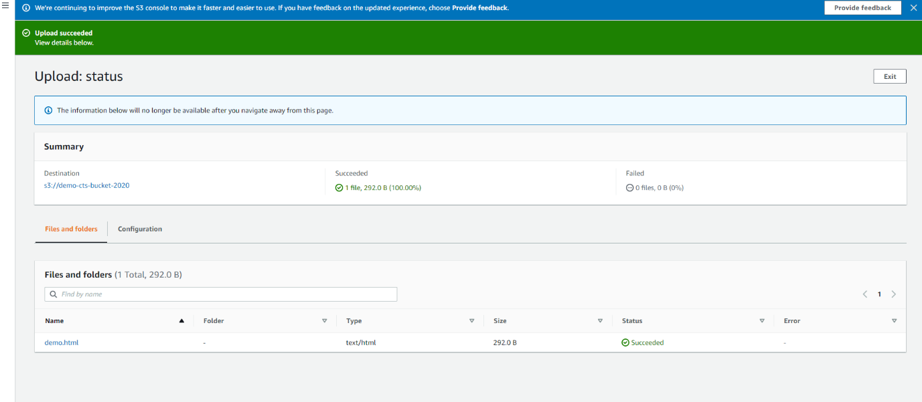

1. Click on one of the objects the is uploaded.

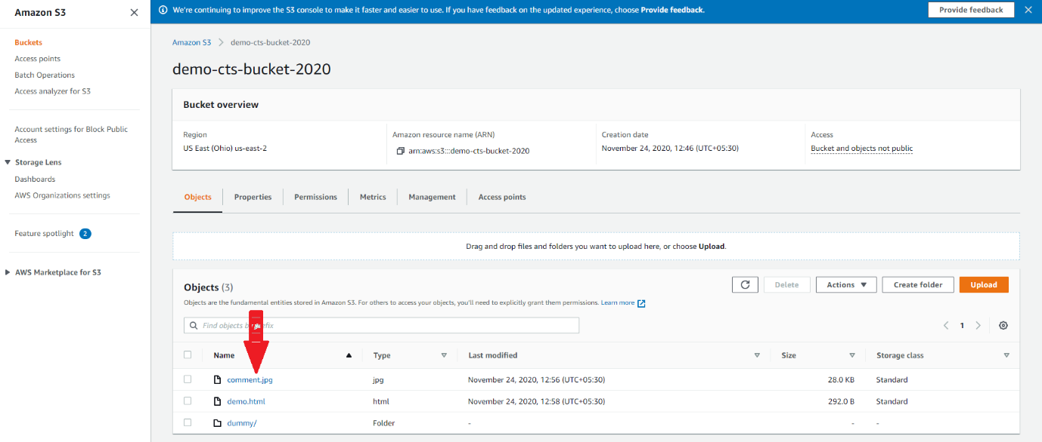

1. You will be taken the details page of the specific object where you can find an Object URL. Click on the Object URL.

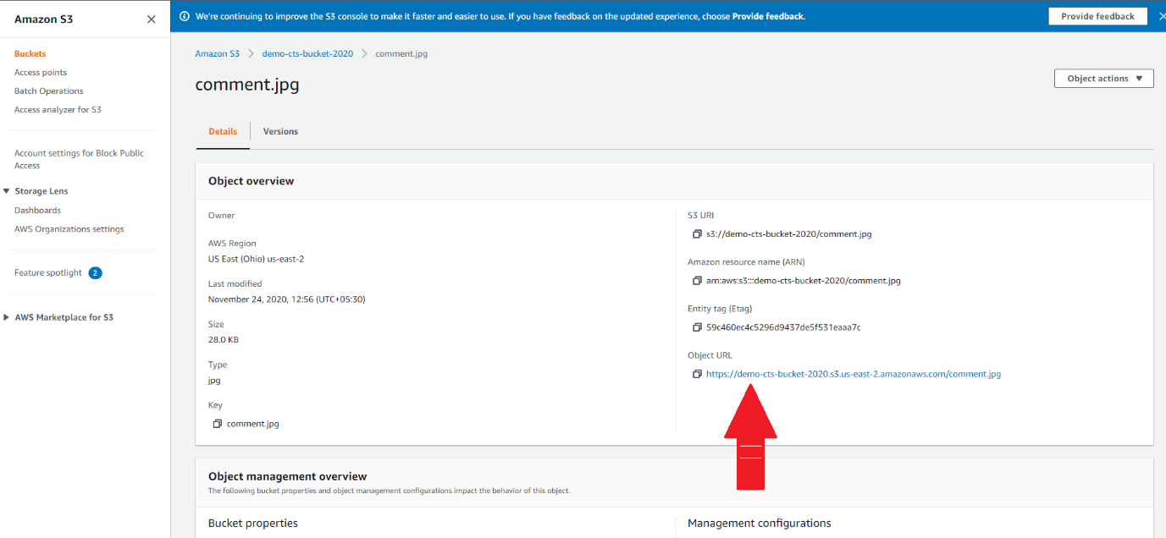

1. You will get the below shown error message.

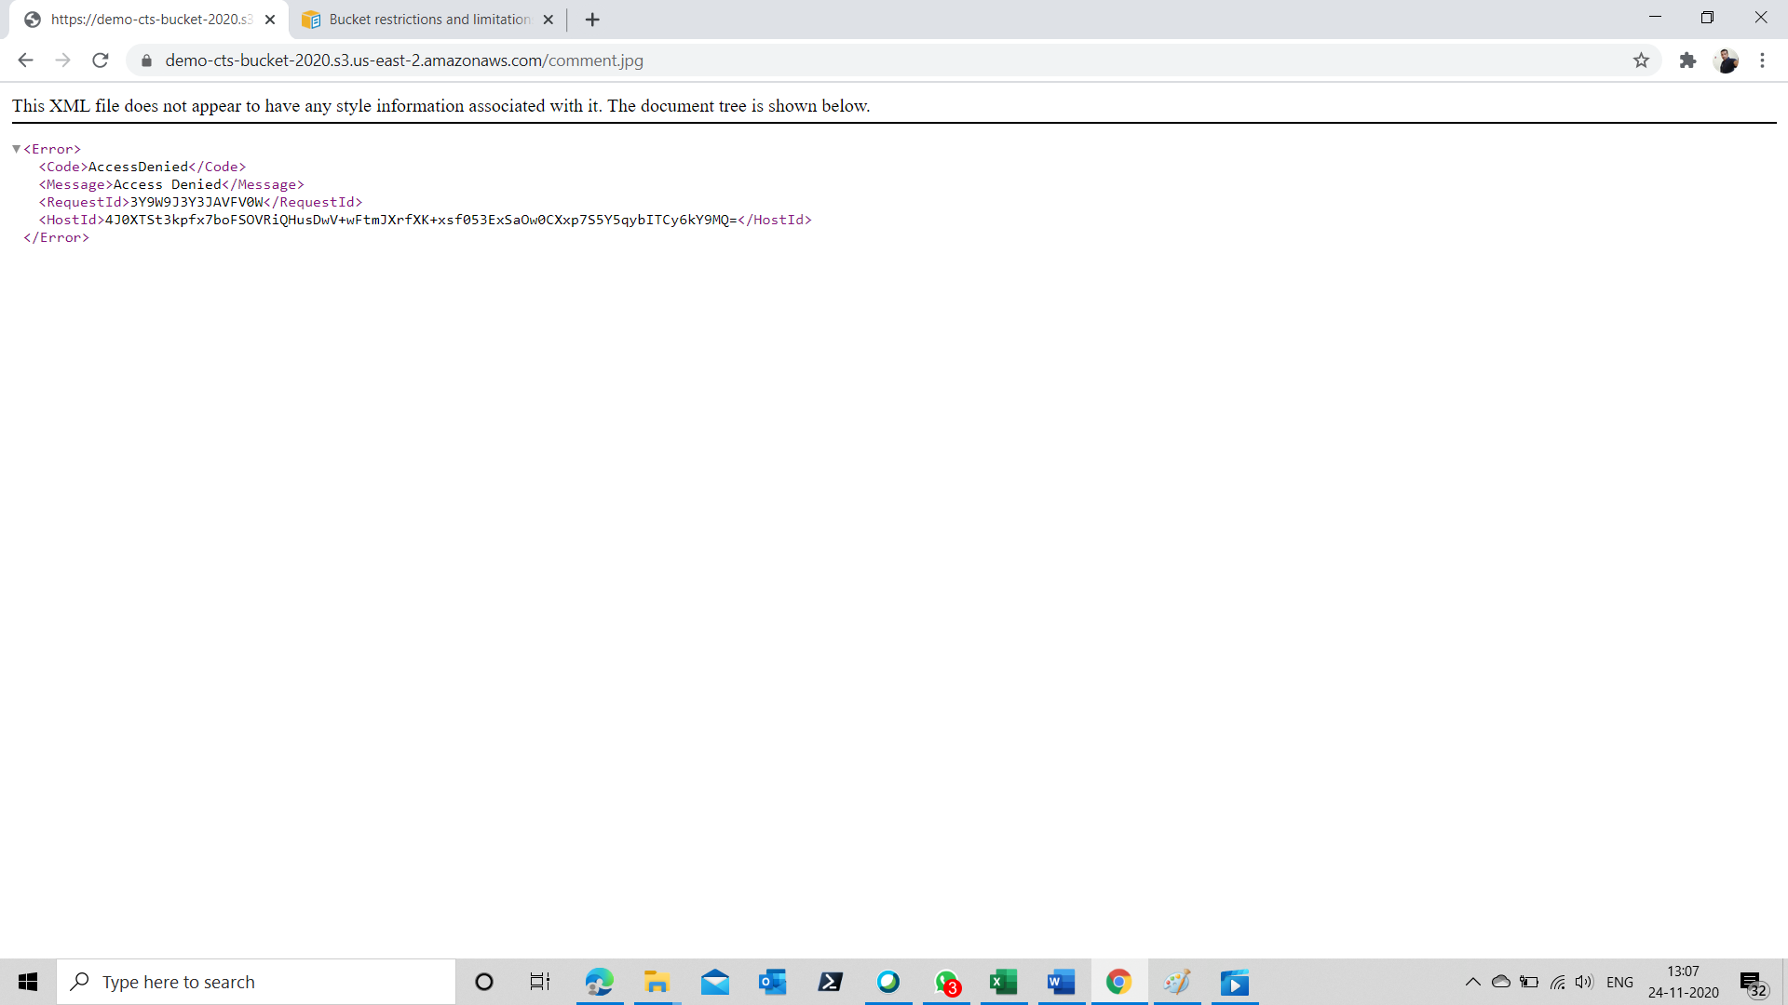

1. This error is because, by default, S3 does not allow public access to the object uploaded. You need to enable public access.
2. Go the to your bucket, select the “Permission” tab.
3. Click on “Edit” button

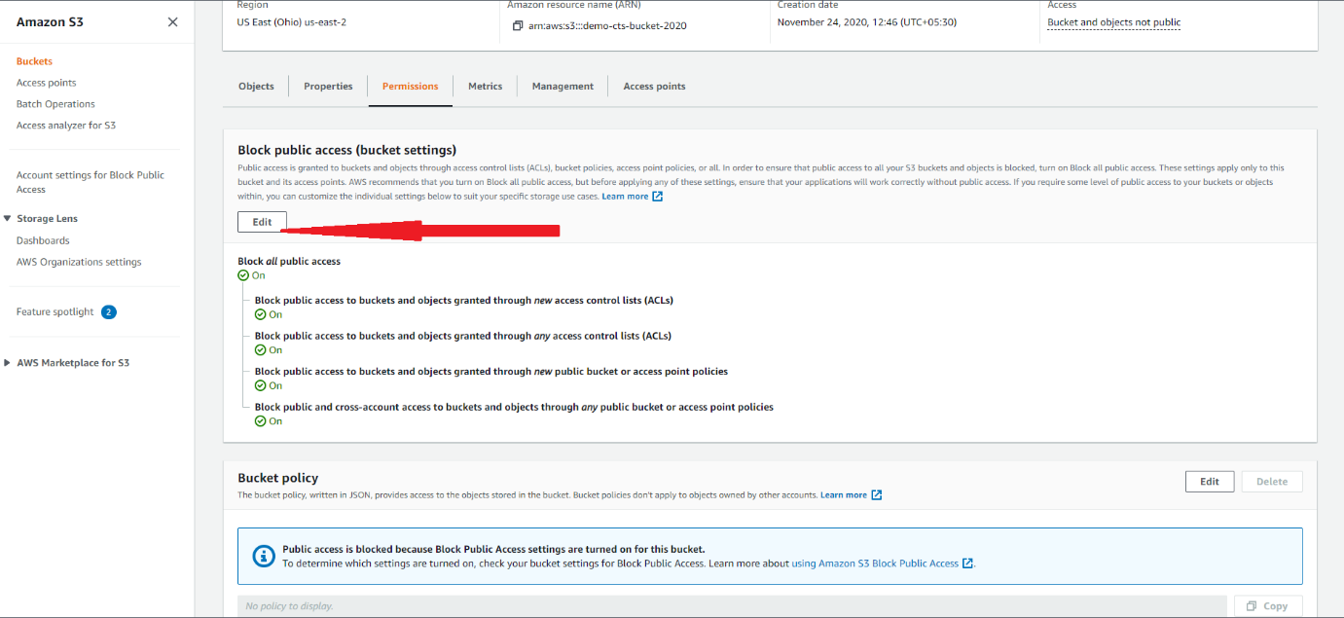

1. And uncheck “Block all public access” checkbox and click on “Save changes” button

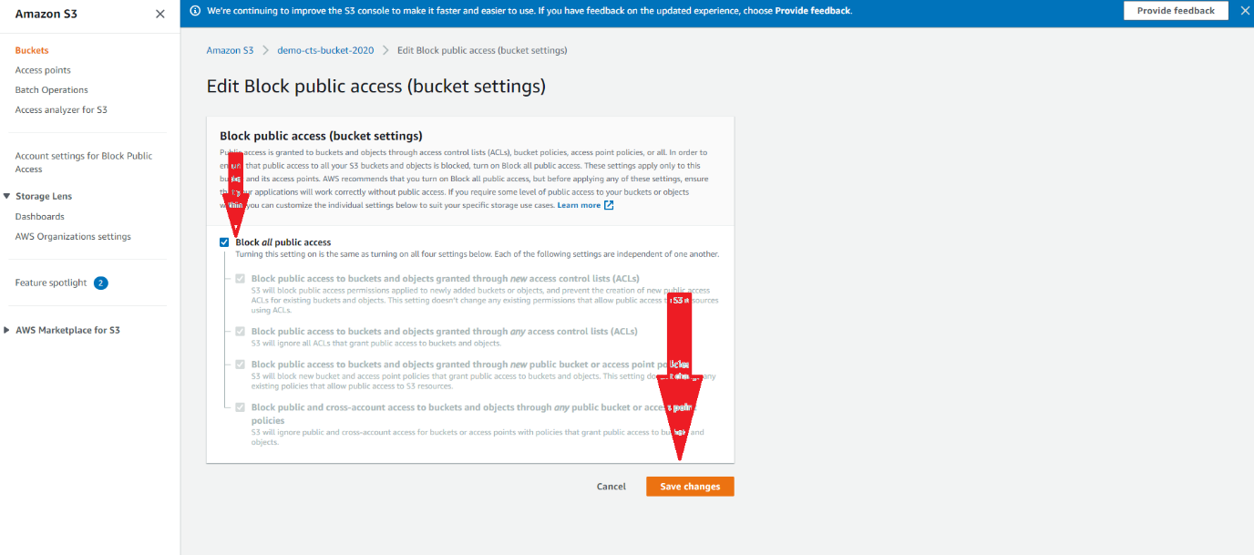

1. Type “confirm” and press “confirm” button

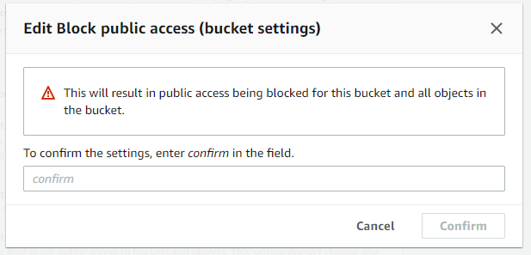

1. Now go to the object details page and try to access the object by clicking on the Object URL. You will get the exact same error message you got in step 21.
2. Go to the Object details page and make the object public by clicking on “Make public” Option as shown below.

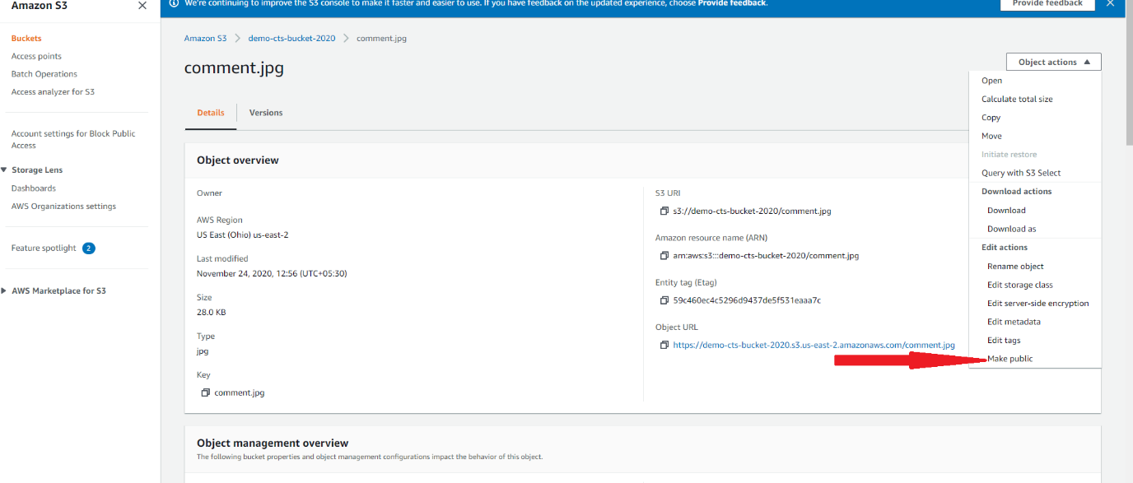

1. Now click on the object URL in the object details page.
2. Click on the “Make public” button in the subsequent screen

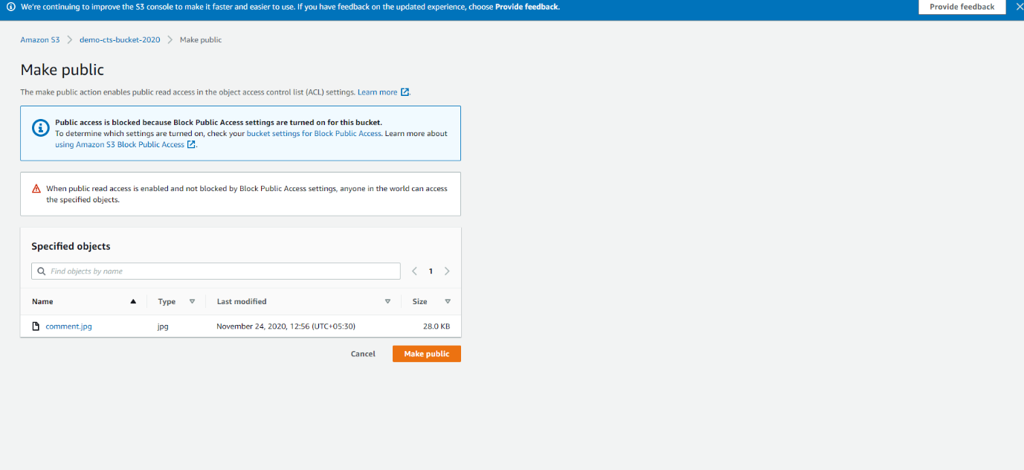

1. Now try to access the object by clicking in the Object URL and you can view the object in the browser

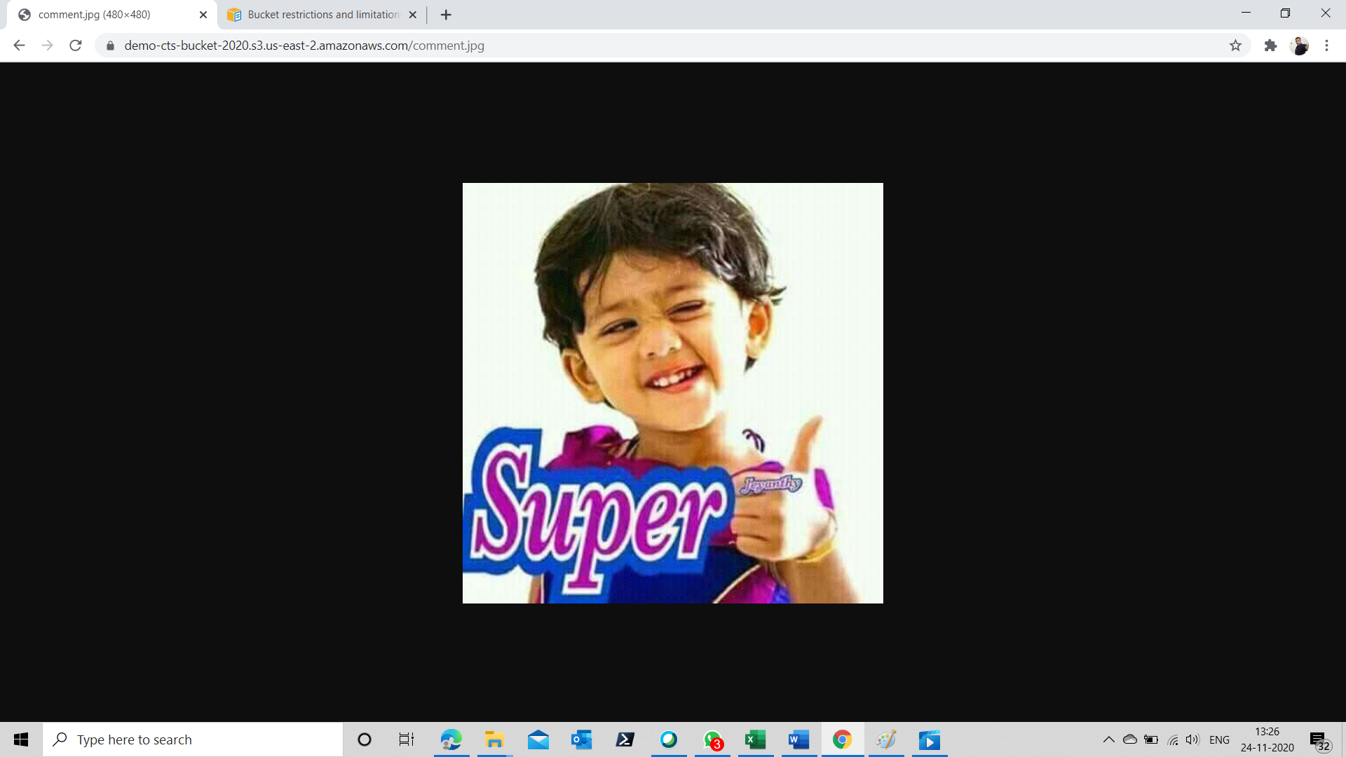

**Deleting the Bucket**

1. Once done, please make sure that you delete your bucket.
2. Select the bucket you want to delete by selecting the radio button as shown below.

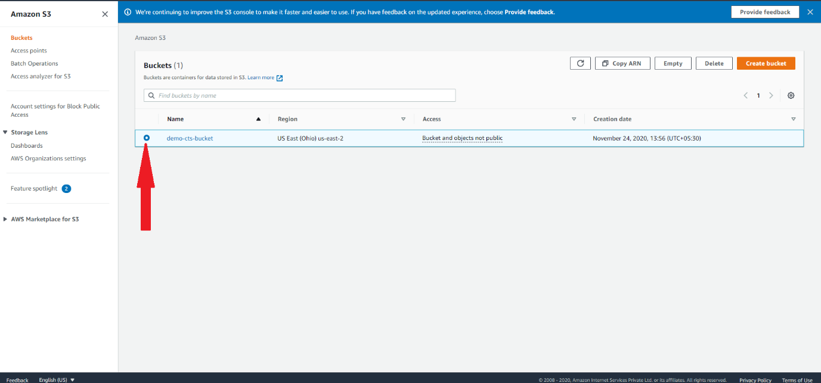

1. Click on the “Empty” button to delete the contents of the bucket.

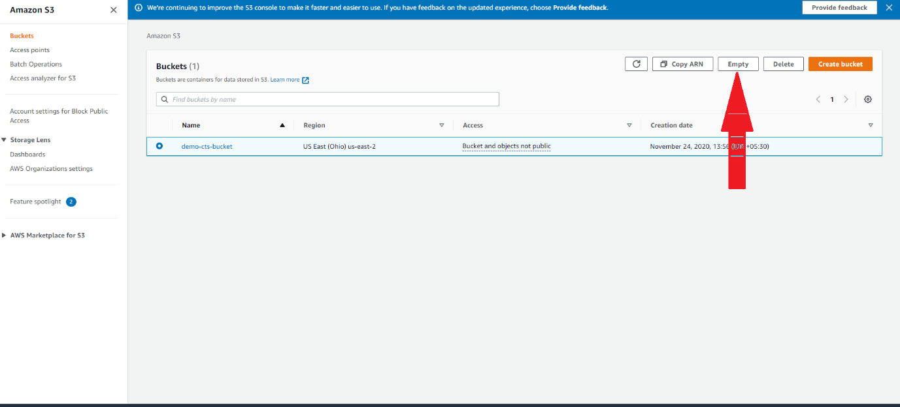

1. Type permanently delete and click on the “Empty” Button

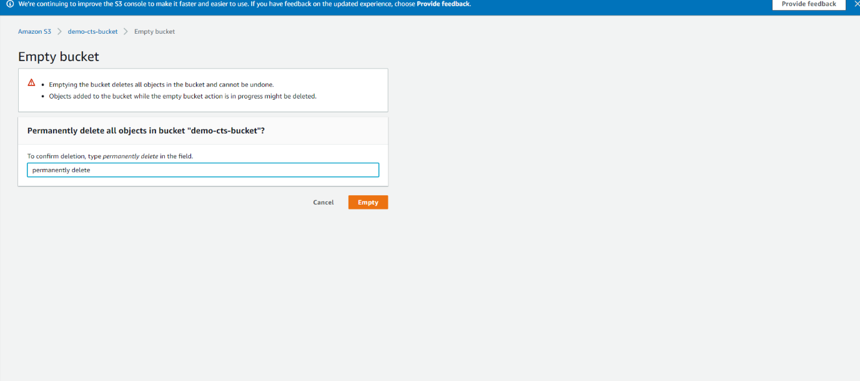

1. Click in “Exit” button and come back the Buckets screen

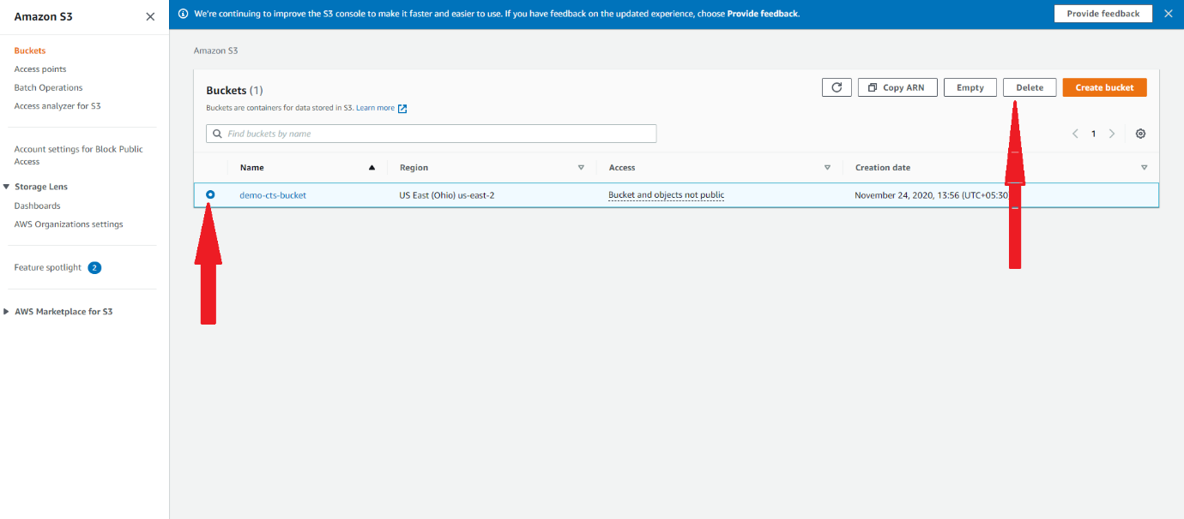

1. Type the name of the bucket you are deleting and click on the “Delete bucket” button.

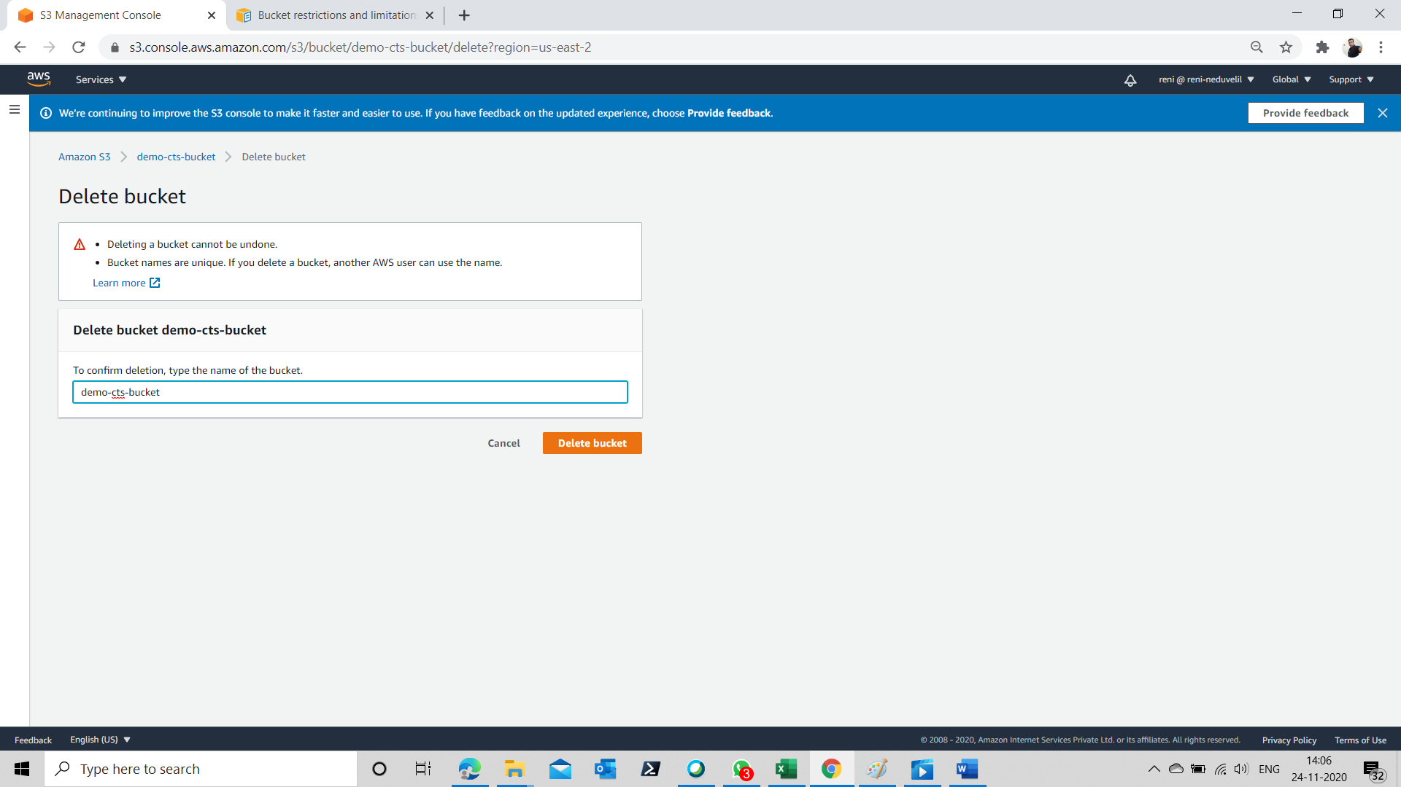

1. Your bucket will be deleted

